HSI

LED String:

Revision History Table:

|  |  |  |  |
| --- | --- | --- | --- |
| Version | Author | Date | Status |
| 1.0 | Caroline Youssef / Mahmoud Gamal | 23/1/2020 | Initial Creation |
| 1.1 | Caroline Youssef / Mahmoud Gamal | 28/1/2020 | Review Changes – under development |
| 1.2 | Caroline Youssef /  Mark Joseph | 5/2/2020 | Header Added- Document Status Table Added |
| 1.3 | Mahmoud Gamal | 6/2/2020 | Changing Block Diagram |
| 1.4 | Mahmoud Gamal | 10/2/2020 | Minor changes |
| 1.5 | Caroline Youssef | 10/2/2020 | Minor Changes |

# Current Document State:

|  |  |  |  |
| --- | --- | --- | --- |
| **Date** | **Version** | **Document Status** | **Author** |
| 23/1/2020 | 1.0 | Draft | Caroline Youssef / Mahmoud Gamal |
| 28/1/2020 | 1.1 | Proposed | Caroline Youssef / Mahmoud Gamal |
| 5/2/2020 | 1.2 | Proposed | Caroline Youssef / Mark Joseph |
| 6/2/2020 | 1.3 | Proposed | Mahmoud Gamal |
| 10/2/2020 | 1.4 | Proposed | Mahmoud Gamal |
| 10/2/2020 | 1.5 | Proposed | Caroline Youssef |

Table of Contents

Current Document State: 2

Requirements 4

Features: 7

Components: 7

# Requirements

Block Diagram

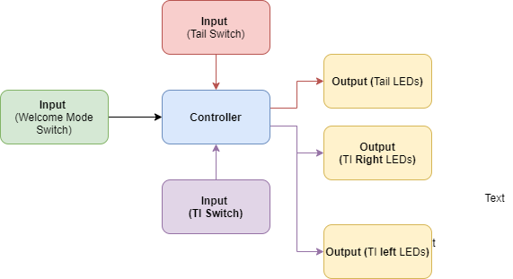

Fig. 1

Pin Layout

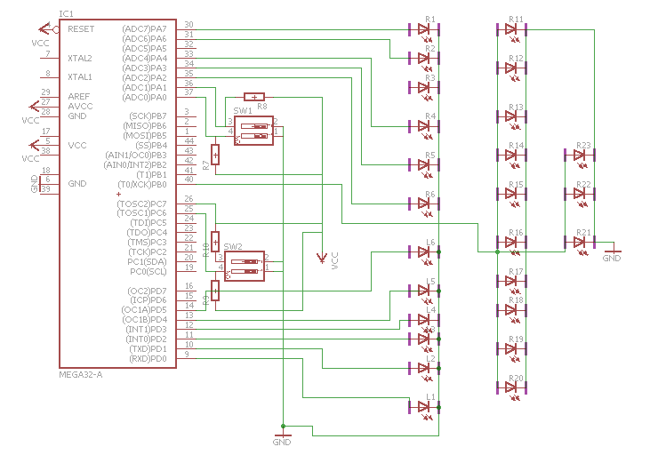

Fig. 2

|  |  |
| --- | --- |
| Pin Number | Pin Configuration |
| 4 | VCC |
| 5 | VCC |
| 6 | GND |
| 9 (L1) | OUTPUT |
| 10 (L2) | OUTPUT |
| 11 (L3) | OUTPUT |
| 12 (L4) | OUTPUT |
| 13 (L5) | OUTPUT |
| 14 (L6) | OUTPUT |
| 25 (TI right switch) | INPUT |
| 26 (TI left switch) | INPUT |
| 30 (R1) | OUTPUT |
| 31 (R2) | OUTPUT |
| 32 (R3) | OUTPUT |
| 33 (R4) | OUTPUT |
| 34 (R5) | OUTPUT |
| 35 (R6) | OUTPUT |
| 36 (MODE switch) | INPUT |
| 37 (Tail switch) | INPUT |
| 40 (Tail Leds) | OUTPUT |

# Features:

* At launch the LEDs will perform welcome mode.
* Use tail switch to perform tail feature.
* Use TI switch for TI feature.

# Components:

In this project, the following components are going to be used:

* 24 LEDs : used to display certain patterns depend on the input signals to the controller (tail pattern or TI pattern) or independent on the input signals(welcome pattern)
* ATMega32 ( Microcontroller) : it is the advanced version of microprocessors. It contains on chip central processing unit (CPU), Read only memory (ROM), Random access memory (RAM), input/output unit, interrupts controller etc.

Therefore a microcontroller is used for high speed signal processing operation inside an embedded system. It acts as major component used in designing of an embedded system.

* 4 Switches : used as input signals to the microcontroller to select a certain pattern of the LEDs